Book idea 1: Springer Handbook of Robotics by like 300 billion people
Book idea 2: Simultaneous Localization and Mapping for Mobile Robots: Introduction and Methods by Juan-Antonio Fernández-Madrigal, José Luis Blanco Claraco

Interviewees:
John J. Leonard (invented SLAM):
Contact info: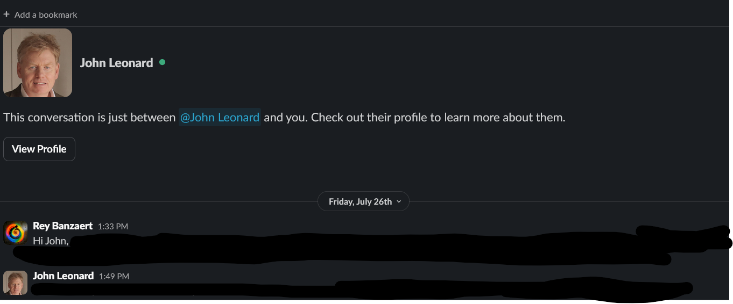
Sangbae Kim (Invented quadrupeds):
Contact info: I can walk to him

Benjamin Katz (made 30 quadrupeds, student of Sangbae and John):
Contact info: (meeting in 40 lol)

